1. What are the features of React?
   * JSX is used with React to describe what the user Interface should look like.
   * A component is essentially a piece of the User Interface. It is like a function that returns HTML elements.
   * Speedy performance as only the changed components are updated.
   * React many extensions for complete application architecture support.
   * One-way Data Binding keeps everything modular and fast.
   * Virtual DOM is a lightweight representation of Real DOM.
2. What is JSX?
   * JSX is a syntax extension to JavaScript.
   * By using JSX, you can write HTML structures in the same file that contains JavaScript code.
   * It is used with React to describe what the User Interface should look like.
3. Can JSX be directly read by the web browsers?
   * Web browsers cannot read JSX directly. It is because they are built to only read regular JS objects and JSX is not regular JavaScript object.
   * For a web browser to read a JSX file, the file needs to be transformed into a regular JavaScript object. For this, Babel is used.
4. What do you understand by Virtual DOM?
   * React keeps a lightweight representation of the Real DOM in the memory, and that is known as the Virtual DOM.
   * When the state of an object changes, Virtual DOM changes only that object in the Real DOM instead of updating all the objects and this makes things really fast.
5. Why use React instead of other frameworks like Angular.
   * Easy creation of dynamic web apps.
   * Reusable Components.
   * Enhanced Performance.
   * Easy Debugging.
   * Unidirectional data flow.
6. What is the difference between ES5 and ES6 standard?
   * Components and Function
     + Extends using in classes, and not needed the word function
     + Var MyComponent = React.createClass 🡺 class MyComponent extends React.Component
     + Render:function(){ 🡺 render(){
   * Exports vs export
     + Module.exports = Component; 🡺 export default Component;
   * Require vs import
     + Var React = require(‘react’); 🡺 var React from ‘react’;
7. How do you create a React app?
   * Install nodejs on the computer.
   * Install text editor of your choice.
   * Create React app using command prompt or terminal (depending on the OS)
     + Create-react-app my-first-app
8. What is an event in React?
   * An event is an action that can be triggered by a User or any System event like pressing a key, a mouse click, etc.
9. How do you create an event in React?
   * <button onClick={this.work}>Do some work!</button>
10. What are synthetic events in React?
    * A synthetic event is an object which acts as a cross-browser wrapper around the browser’s native event.
    * It combines the behavior of different browser’s native event into one API an this makes sure that events are consistent across different browsers.
11. Explain how Lists work in React?
    * Lists display data in an ordered format.
    * Traversal of lists is done using the map() function.
12. Why is there a need of using keys in Lists?
    * Keys are very important in Lists due to the following reasons:
      + A key is unique identifier.
      + It is a used to identify which items have changed, updated, or deleted from the Lists.
      + It also helps to determinate which components need to be re-rendered instead of re-rendering the all the components every time.
      + It increases performance as only the changed components are re-rendered.
13. What are Forms in React?
    * Using Forms, users can interact with the application an enter the required information whenever needed.
    * Forms can contain certain elements such as text fields, buttons, checkbox, etc.
    * Forms are used for many different tasks such as user authentication, searching, filtering, etc.
14. How do you create Forms in React?

render(){

return(

<form onSubmit={this.handleSubmit.bind(this)}>

….

<input type=”submit” value=”Submit”/>

</form>

);

}

1. How do you write comments in React?
   * Single line: /\* This is React App\*/
   * Multi line /\*…..\*/
2. What is arrow fuction and how is it used?
   * Arrow function is a short way of writing a function in React.
   * It is not necessary to bind ‘this’ inside constructor when using arrow function.
   * <MyInput onChange={this.handleChange.bind(this)}/>
   * <MyInput onChange={ (e) => this.handleOnChange(e) }/>
3. How is React different from React Native?
   * 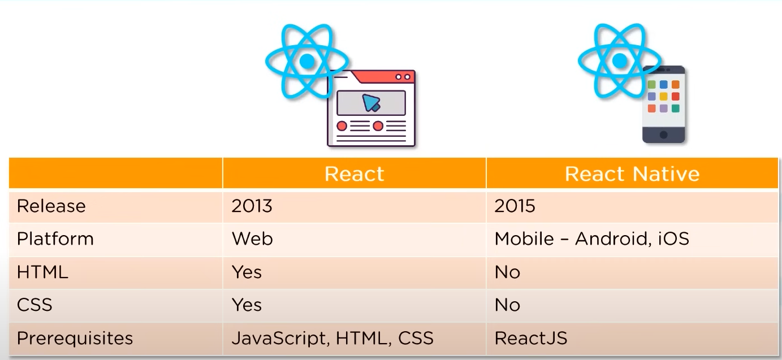
4. How is React different from Angular?
   * 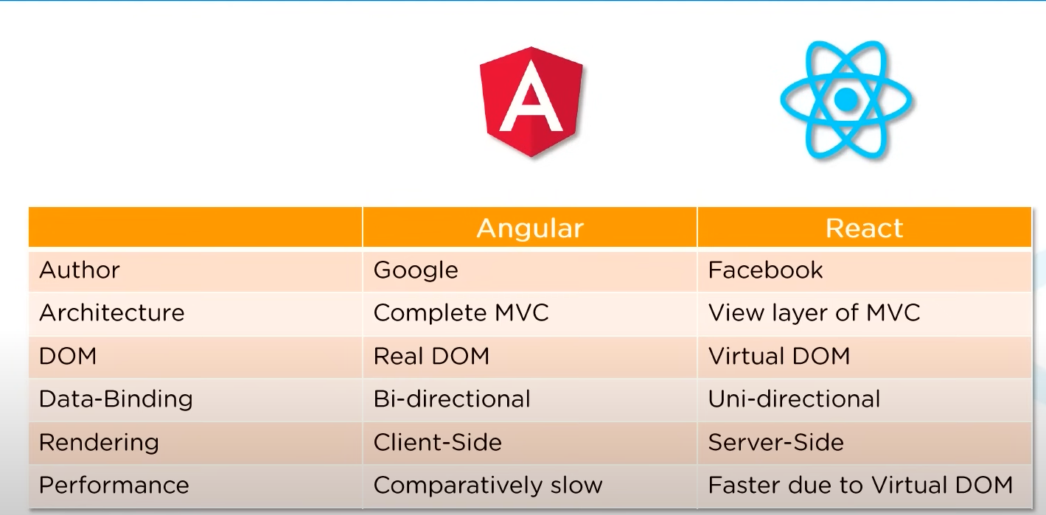
5. What are Components in React?
   * Components are the building blocks of any React application, and a single app usually consists of multiple components.
   * It splits the User Interface into independent, reusable pieces that can be processed separately.
   * A component is essentially a piece of the User Interface.
6. What is the use of render() in React?
   * It is compulsory for each component to have a render() function.
   * Render() function returns the HTML which is to be displayed in a component
     + 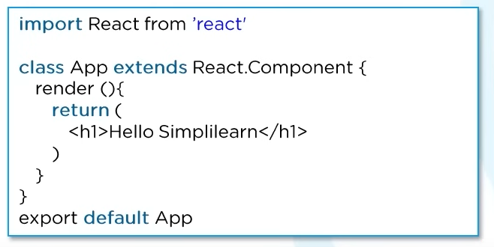
   * If you need to render more than one element, all the elements must be inside one parent tag like <div>, <form>
7. What is State in React?
   * Sate of a component is an object that holds some data.
   * This data influences the output of a component.
8. How do you implement State in React?
   * 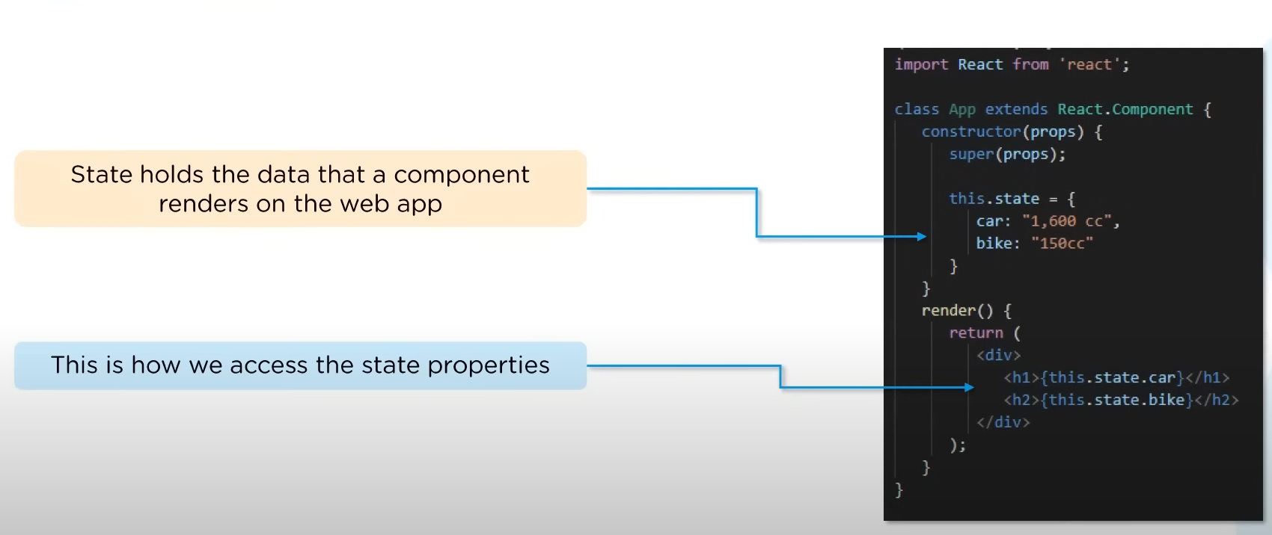
9. How do yoy updated the state of a component?
   * Using setState()
   * 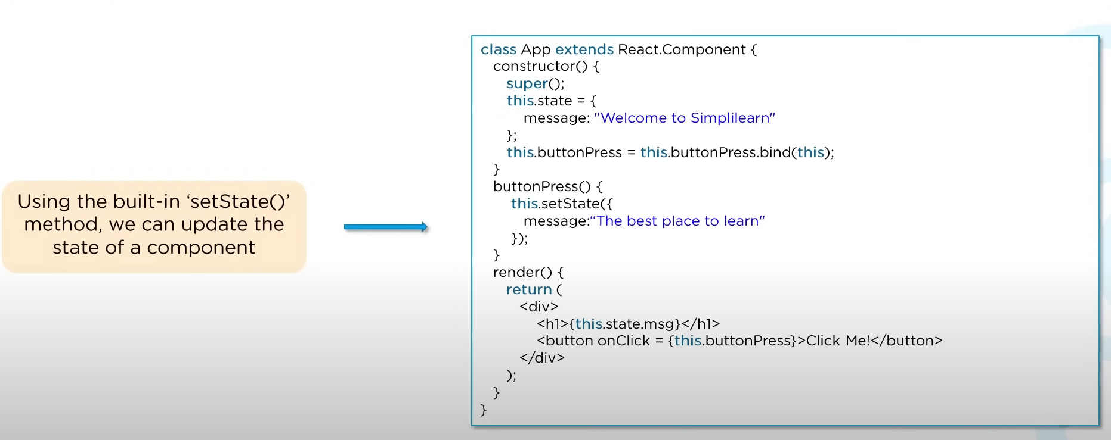
10. What are Props in React?
    * Props is short for properties, that allow us to pass arguments or data to components.
    * Props are passed to components in the way similar to that of HTML-tag attributes.
11. How do you pass props between components?
    * This is how we access the properties passed to a component
      + 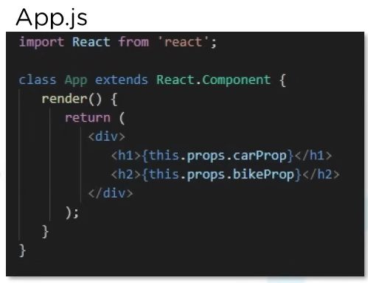
    * This is how we pass the properties to a component
      + 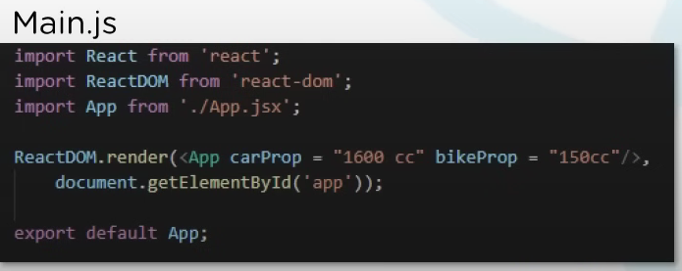
12. What are the differences between state and props?

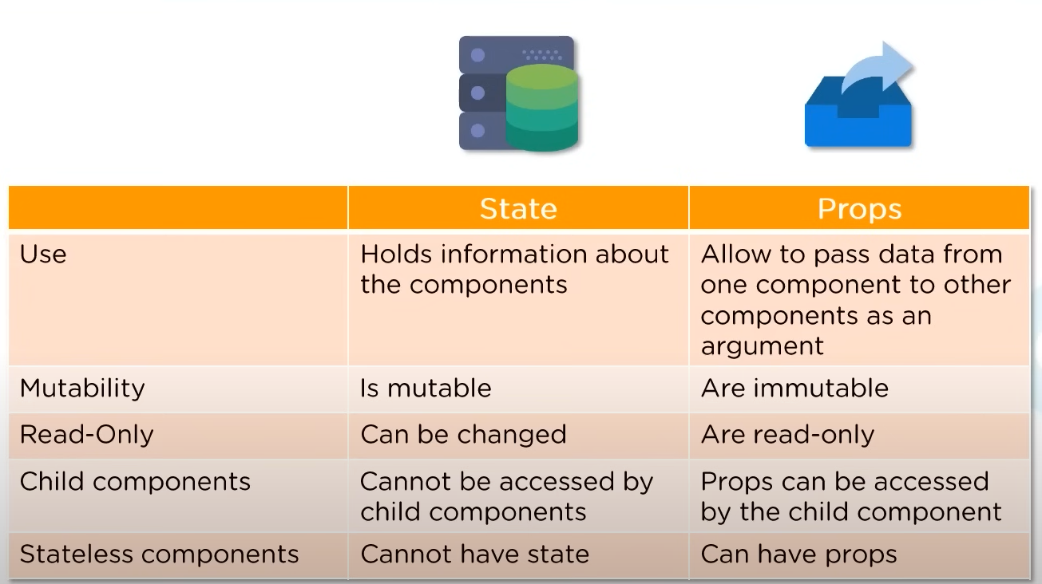

1. What is a higher order component in React?
   * Higher order components act as a container for other components.
   * This helps in keeping components simple and induces re-usabulity.
   * The are generally used when a common logic has to be used by multiple components.
2. How can you embed two or more components into one?

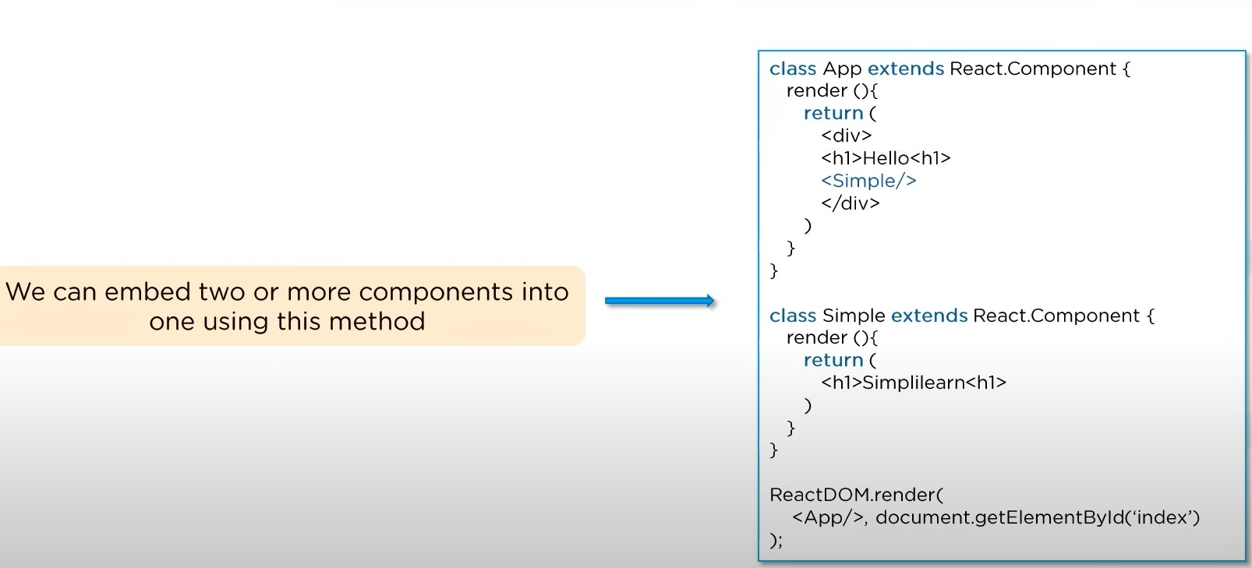

1. What are the differences between class and functional components?

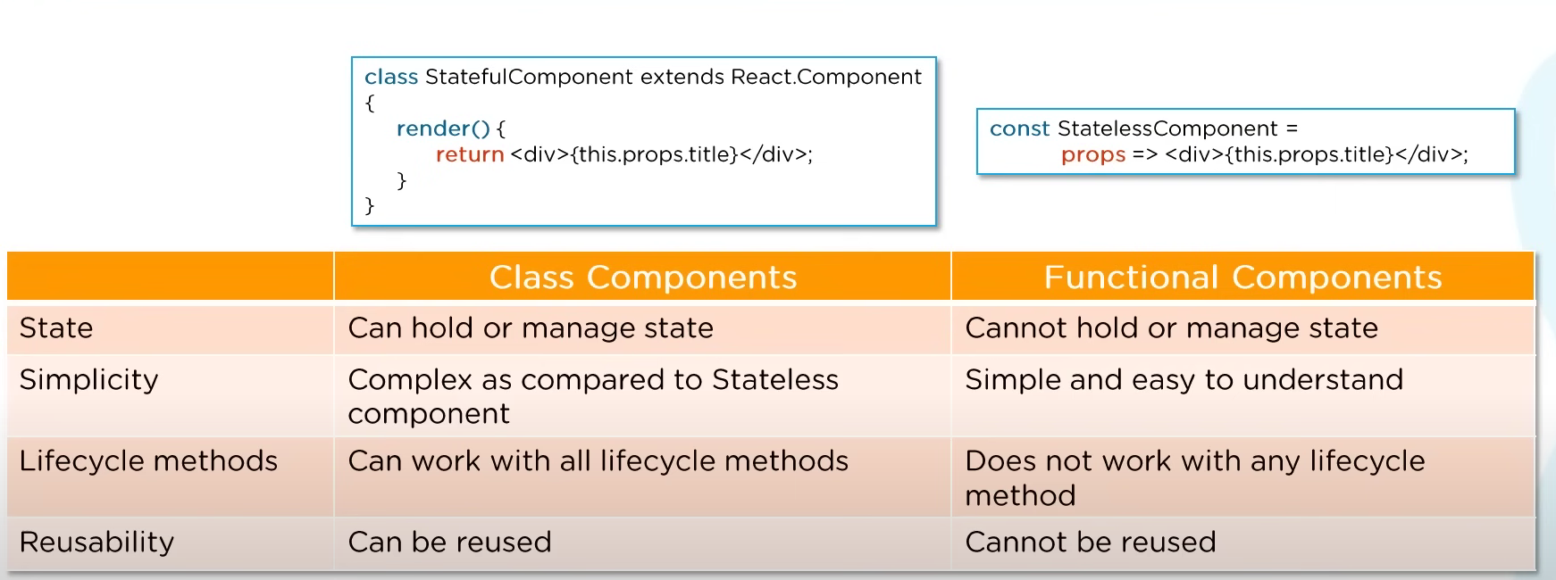

1. Explain the lifecycle methods of Components?

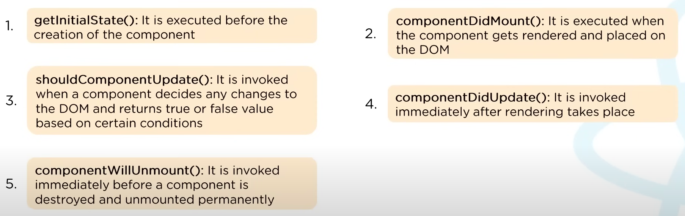

1. What is Redux?
   * Redux is an open-source, JavaScript library used to manage application state.
   * React uses Redux for building the user interface.
2. What are the components of Redux?
   * Store: It holds the state of the application.
   * Action: It is the source information for the store.
   * Reducer: It specifies how the application’s state changes in response to actions sent to the store.
   * 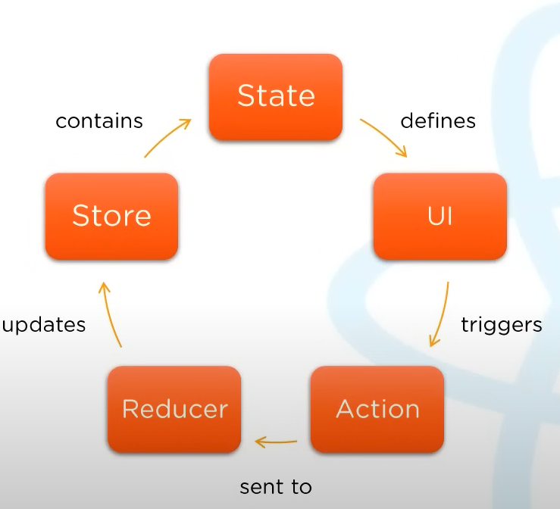
3. What is Flux?
   * Flux is the application architecture that Facebook uses for building web applications.
   * 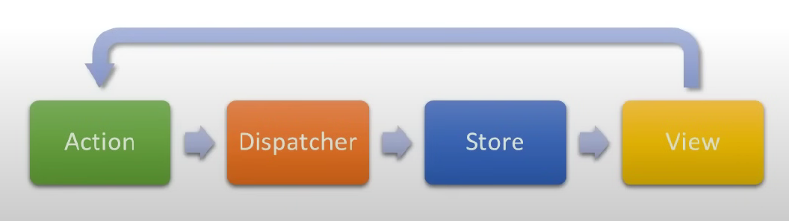
4. How is Redux different from Flux?

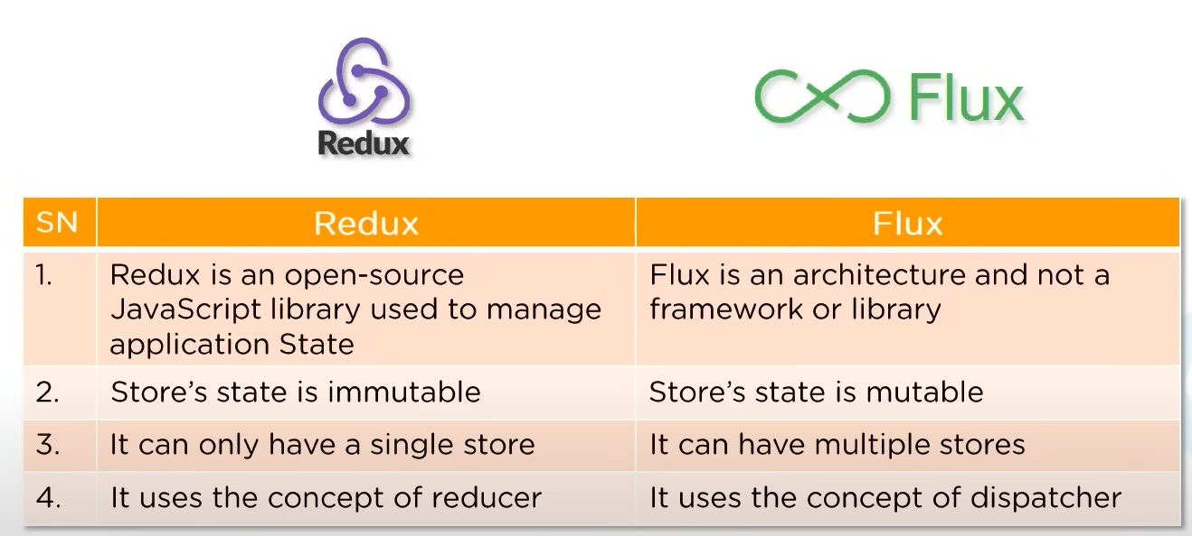

1. What is React Router?
   * React Router is a package which is used to create Routing in a React application.
2. Why do we need React Router?
   * React Router is used for developing single page web applications.
   * It allows multiple views in a single application by defining multiple routes in the React application.
3. How is React Routing different from Conventional Routing?

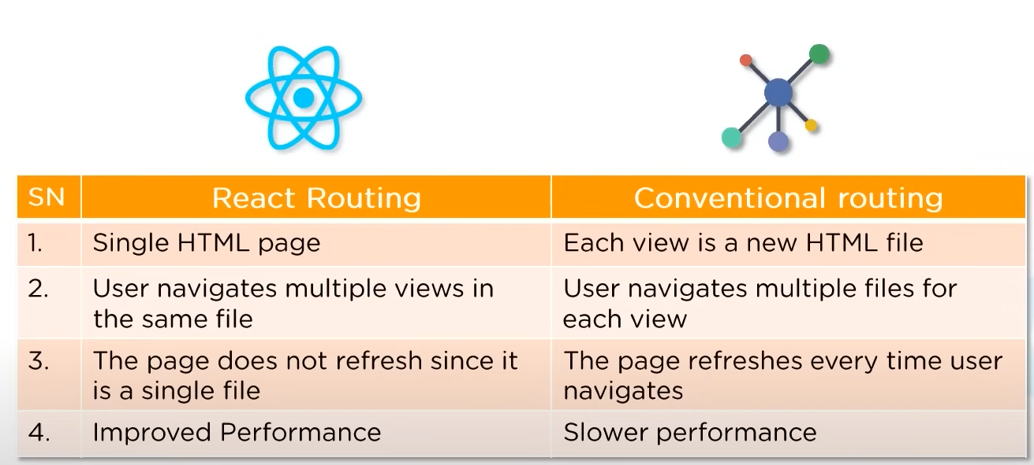

1. How do you implement React Routing?

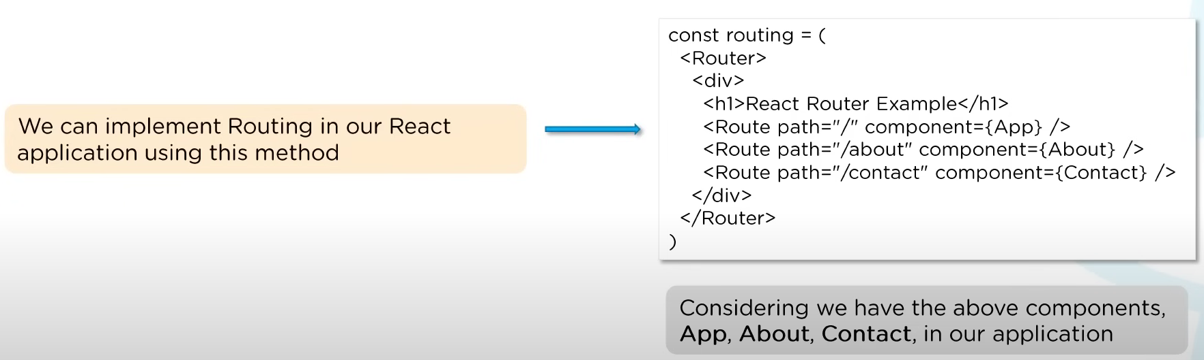

1. How do you style React component?
   * 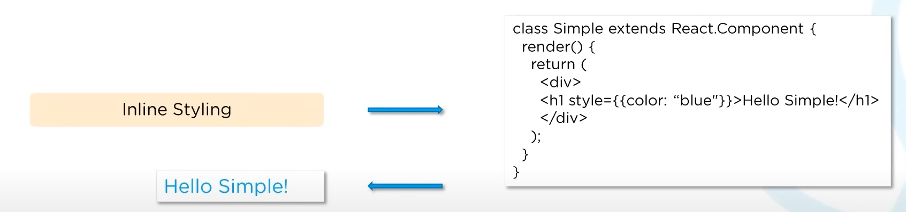
   * 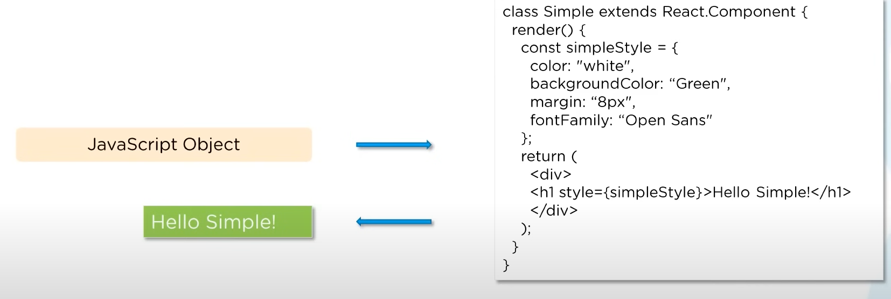
   * 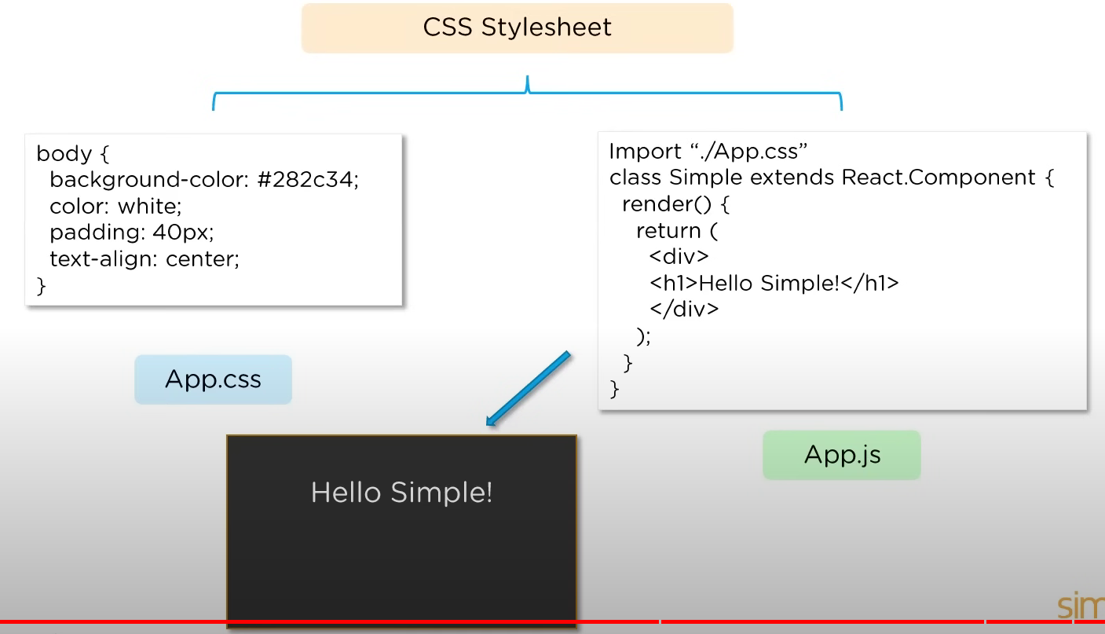
2. Explain the use of CSS Modules in React?

